Linked-List Operations:
Insertion:
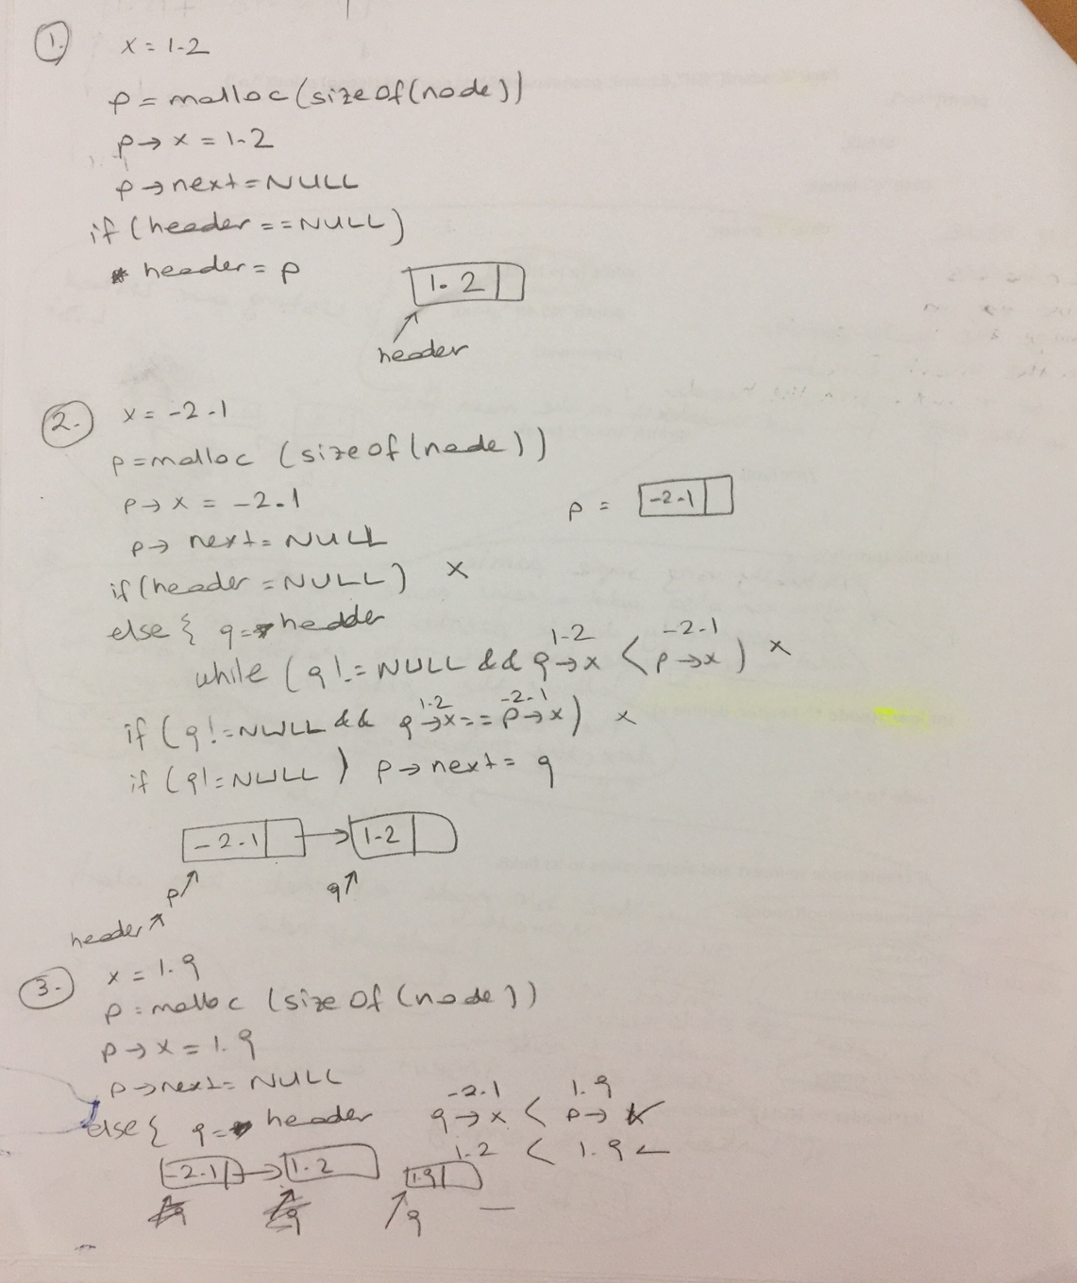
Search: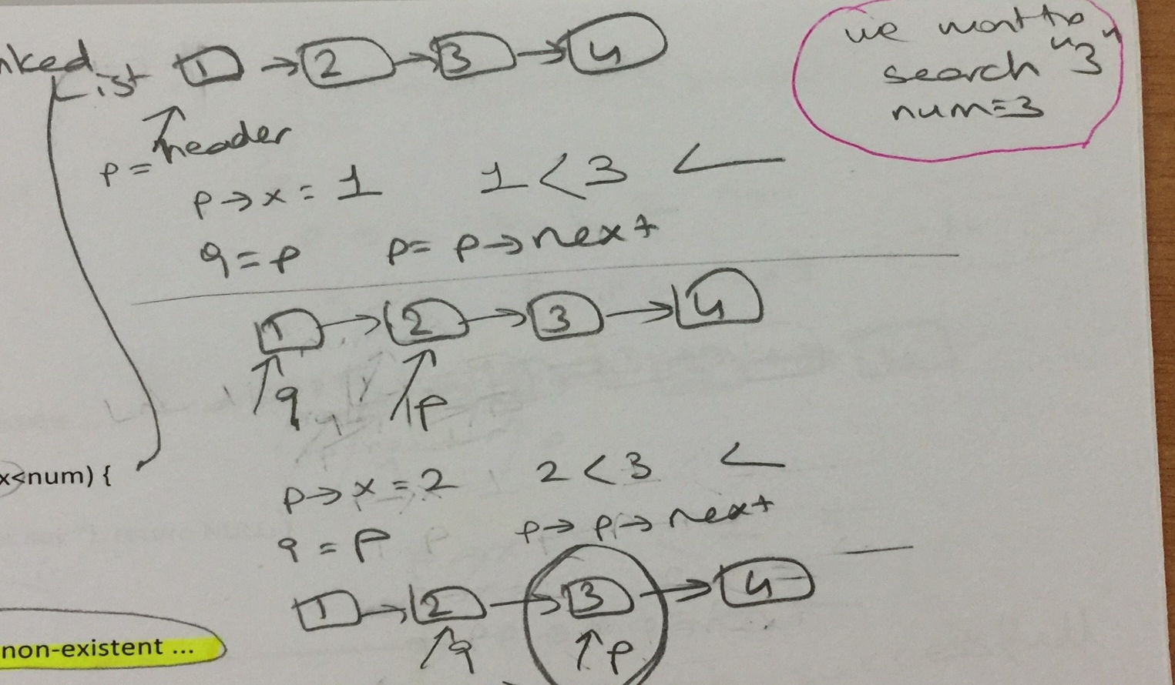

- (Quiz-2017) (6 pts)
What value does function mystery return when called with a value of 4?

int mystery ( int number )
{
if ( number <= 1 )
return 1;
else
return number * mystery( number – 1 );
}

24

- (Quiz-2017) What is the output of the following program?

main()
{
int a[] ={1,2,9,8,6,3,5,7,8,9};
int *p=a+1;
int *q=a+6;
printf("\n%d ", q-p);
}
5

- 2010-Midterm (15 pts)

Consider the data records R₁,...,R_{n}, and a program processing these data. Its access pattern to these data records is that each data record R_{i} is accessed n-i times. That is, R₁ is the most frequently accessed record (n-1 times) while R_{n} is the least frequently accessed one (only once).

Construct a linked list to keep these records in the main memory so as to minimize the total access time, where one time unit is the time taken to compare the key of a linked list with the key searched! Calculate the total access time for your linked list in terms of n!

- (2015-Quiz)Select the correct choice (4 pts)
An algorithm that requires __________ operations to complete its task on n data elements is said to have a linear runtime.
a. n³ + 9
b. 3 n² + 3 n + 2
c. 2 n + 1
d. 6

- (2015-Quiz)Select the correct choice (4 pts)
In general, linked lists allow:
a. Insertions and removals anywhere.
b. Insertions and removals only at one end.
c. Insertions at the back and removals from the front.
d. None of the above.

- 2013-Midterm (10 pts)

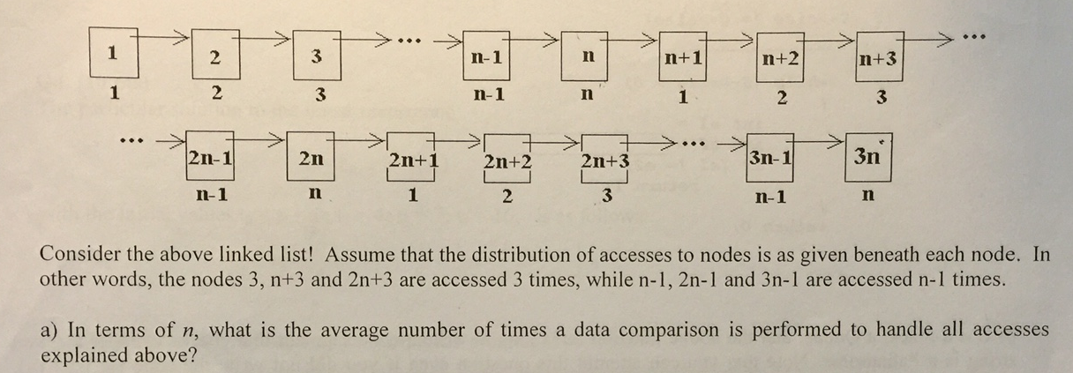
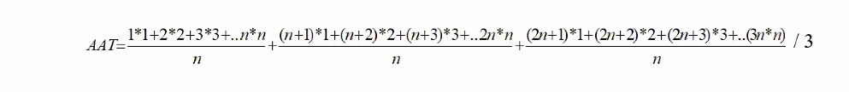

7. 2011-Midterm(10pts)
Consider the algorithms A₁…A₅ solving the same problem with execution times, t₁(n),…,t₅(n), of the following asymptotic upper bounds. Put the algorithms in order regarding their execution speed from the fastest to the slowest!
- O(3^{n})
- O(n^{n})
- O(n2^{n})
- O(n!)
- O(log(n²n^{n}))

- 2006-Midterm (20pts)
Consider the following matrix m!
i/j | 1 | 2 | 3 | 4 | 5
1 | 1 | 2 | 3 | 4 | 5
2 | 0 | 4 | 9 | 16 | 25
3 | 0 | 0 | 27 | 64 | 125
4 | 0 | 0 | 0 | 256 | 625
5 | 0 | 0 | 0 | 0 | 3125

The first row indicates the column index (i.e., j) values, whereas the first column shows the row index (i.e., i) values.
How can you represent m most efficiently (i.e., allocating the minimum amount of memory space with no dramatical changes in access time)? Show all your work and provide a formula (or a single assignment in C language)!

- 2015-Midterm (10 pts)
Consider the following matrix m:
i /j | 1 | 2 | 3 | 4 | 5 | 6 | 7
1 | 2 | 0 | 0 | 0 | 0 | 0 | 8
2 | 0 | 10 | 0 | 0 | 0 | 14 | 0
3 | 0 | 0 | 30 | 0 | 32 | 0 | 0
4 | 0 | 0 | 0 | 68 | 0 | 0 | 0
5 | 0 | 0 | 128 | 0 | 130 | 0 | 0
6 | 0 | 218 | 0 | 0 | 0 | 222 | 0
7 | 344 | 0 | 0 | 0 | 0 | 0 | 350

In order to represent m most efficiently (allocating minimum amount of memory space)) provide a formula in terms of i and j.

- 2011-Midterm(20pts) (HOME EXERCISE)
Consider the following matrix m!
i/j | 1 | 2 | 3 | 4 | 5
1 | 5 | 3 | 1 | -1 | -3
2 | 0 | 9 | 1 | 1 | 9
3 | 0 | 0 | 1 | -1 | -27
4 | 0 | 0 | 0 | 1 | 81
5 | 0 | 0 | 0 | 0 | -243

The first row indicates the column index (i.e., j) values, whereas the first column shows the row index (i.e., i) values.
How can you represent m most efficiently (i.e., allocating the minimum amount of memory space with no dramatical changes in access time)? Show all your work and provide a formula (or a single assignment statement in C language)!

